- Create a stored procedure that takes in IN parameters for all the columns in the Worker table and adds a new record to the table and then invokes the procedure call.
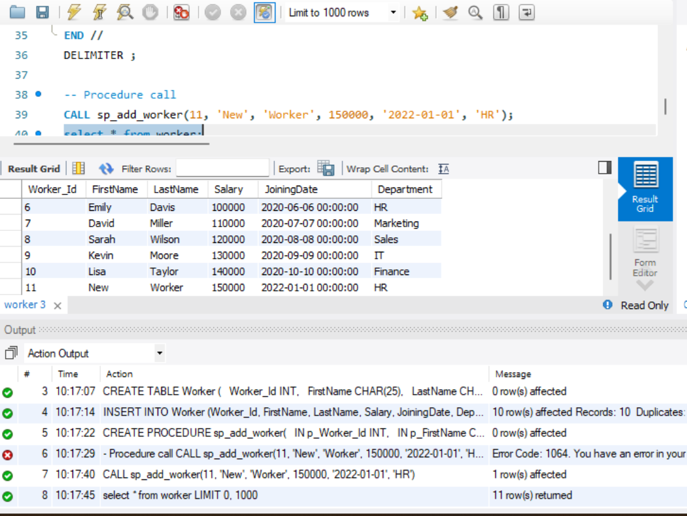
- Write stored procedure takes in an IN parameter for WORKER_ID and an OUT parameter for SALARY. It should retrieve the salary of the worker with the given ID and returns it in the p_salary parameter. Then make the procedure call.
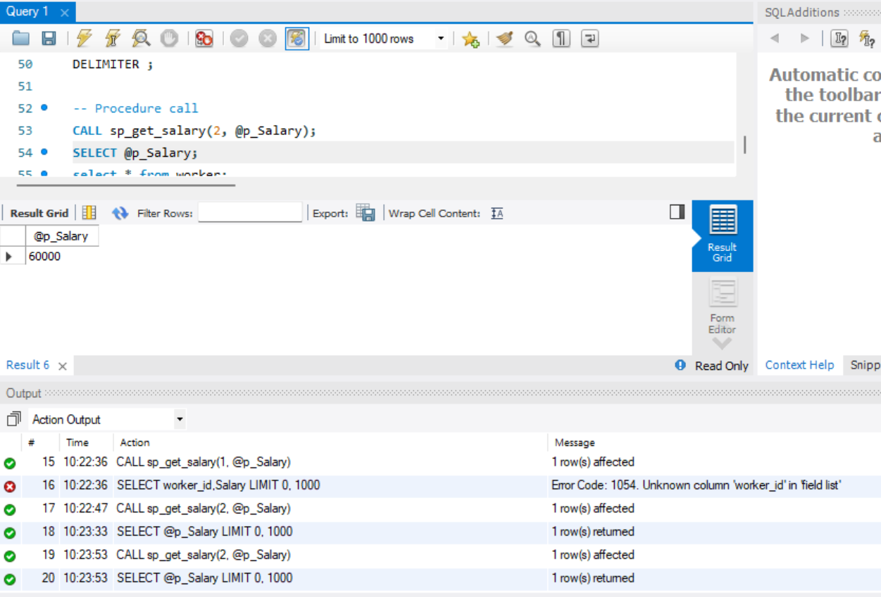
- Create a stored procedure that takes in IN parameters for WORKER_ID and DEPARTMENT. It should update the department of the worker with the given ID. Then make a procedure call.
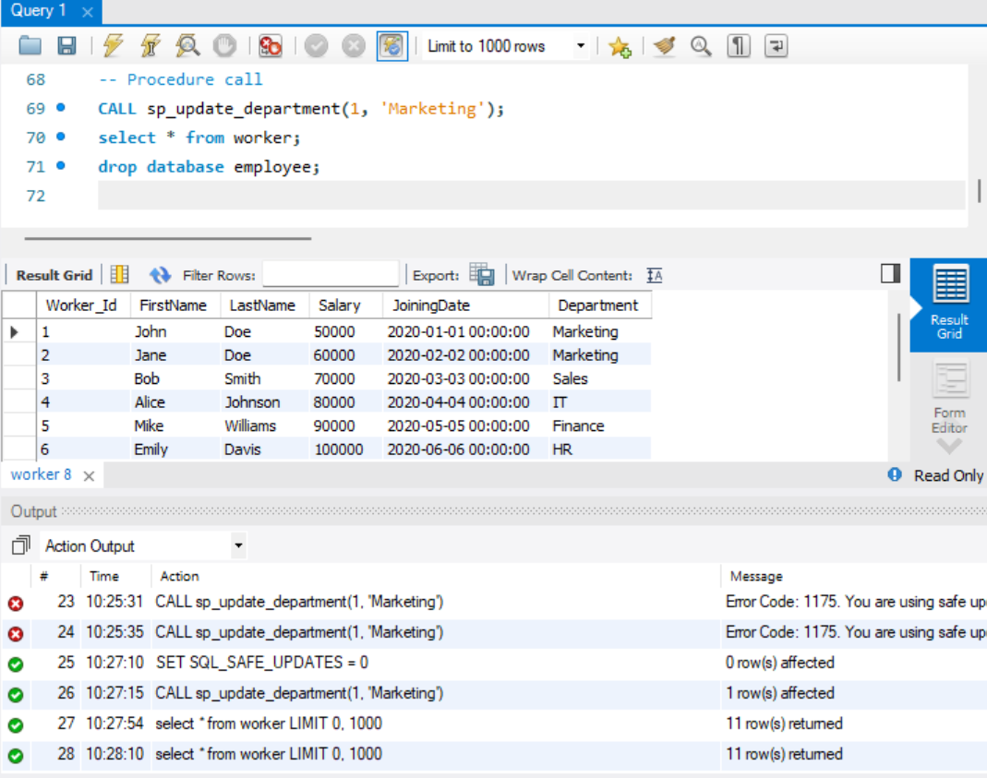
- Write a stored procedure that takes in an IN parameter for DEPARTMENT and an OUT parameter for p_workerCount. It should retrieve the number of workers in the given department and returns it in the p_workerCount parameter. Make procedure call.
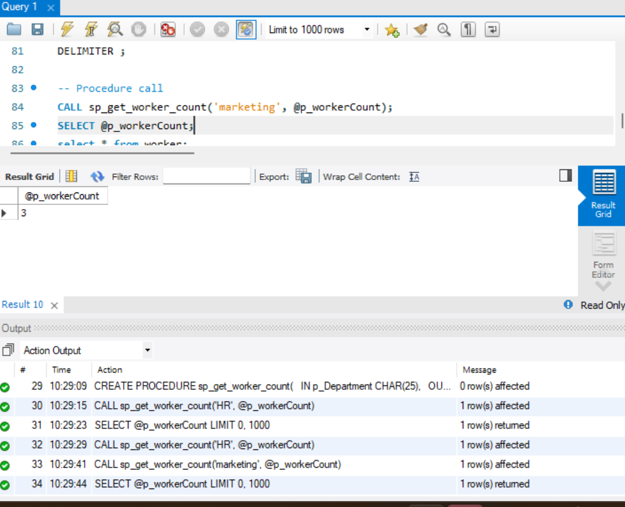
- Write a stored procedure that takes in an IN parameter for DEPARTMENT and an OUT parameter for p_avgSalary.
